通信用室内双芯2.0紧套光缆
Indoor dual-core 2.0 tight-sleeve optical cable for communication
Cable Construction Parameter 光缆结构参数
紧套光纤芯数  Tighten the number of fiber cores | 2F
紧套光纤颜色 Tight fiber color | G652D
紧套光纤颜色 Tight fiber color | 白+黄
紧套光纤材料 Tight sleeve fiber material | PVC
紧套光纤外径(-0.05mm) Tight sleeve fiber outer diameter | Ø0.9
紧套光纤一次剥离度(±0.5Cm) Tight sleeve fiber one-time peeling degree | 1.5cm
紧套光纤外径不圆度 The outer diameter of the tight sleeve fiber is not round | ≤2%
紧套光缆外径（±0.05mm） Tight sleeve optical cable outer diameter | 1.85*3.8
紧套光缆壁厚（±0.05mm） Tight sleeve cable wall thickness | 0.5
紧套光缆外护材料 Tight sleeve of optical cable outer shield material | PVC
紧套光缆外护颜色 Tight sleeve optical cable outer cover color | 黄色
芳纶型号及填充数 Aramid model and filling number | 1100D*3股*2C
抗拉（N） Tensile resistance | 短期 | 长期
抗拉（N） Tensile resistance | 320 | 200
最小弯曲半径（mm） Minimum bending radius | 动态20D | 静态10D

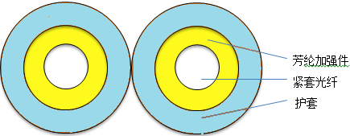

Optical Fiber Parameter 光纤参数
光纤品牌  Fiber optic brand | 长飞
光纤类型  Fiber type | G652D
芯径  Core diameter | 9μm
芯不圆度  Core incompleteness | ≤5%
包层直径  Cladding diameter | 124.8 ± 1μm
包层不圆度  Cladding is not round | ≤ 1%
涂层直径  Coating diameter | 245 ± 7μm
涂层/包层同心度误差 Coating/cladding concentricity error | ≤12um
涂层不圆度  The coating is not round | ≤6%
芯/包层同心度误差  Core/cladding concentricity error | ≤1um
衰减系数  Attenuation factor | ≤0.4dB/km at 1310nm,  ≤ 0.3dB/km at 1550nm

